Assignment 5 worksheet

MPL CHAPTER 8 programMING PROJECTS

This ASSIGNMENT contains the following activities:

|  |  |
| --- | --- |
| Activity 5.1 | Choosing Your Programming Projects |
| Activity 5.2 | Submitting your Solution |

|  |  |
| --- | --- |
| Activity 5.1 | Choosing your Programming Project |
| Overview | In Activity 5.1, you choose your Programming Project. |

1. Review MyProgrammingLab Chapter 8, “Programming Projects” and choose one out of three projects:
2. Area Class (73088)
3. A LandTract Class (71119)
4. Parking Ticket Simulator (73089)

**Note:**

* These 3 “Programming Projects” descriptions are included at the end of this Doccument (See Appendix).

|  |  |
| --- | --- |
| Activity 5.2 | Submitting Your Solution |
| Overview | In Activity 5.2, you submit your solution. |

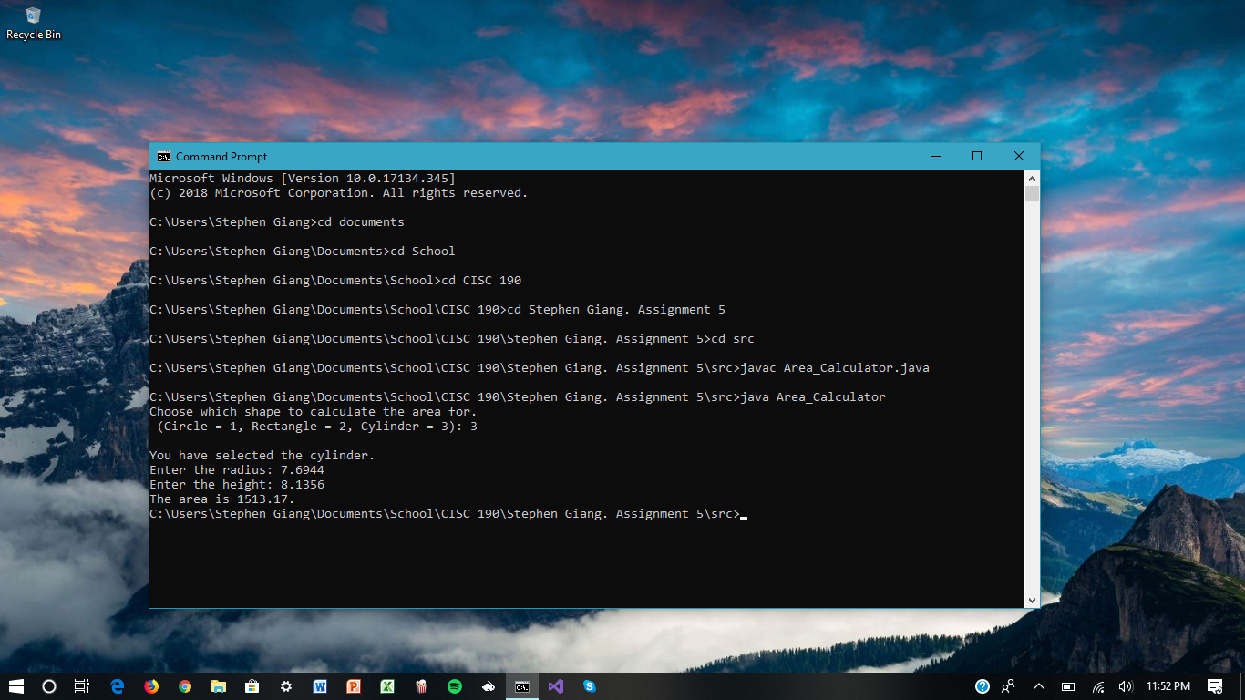

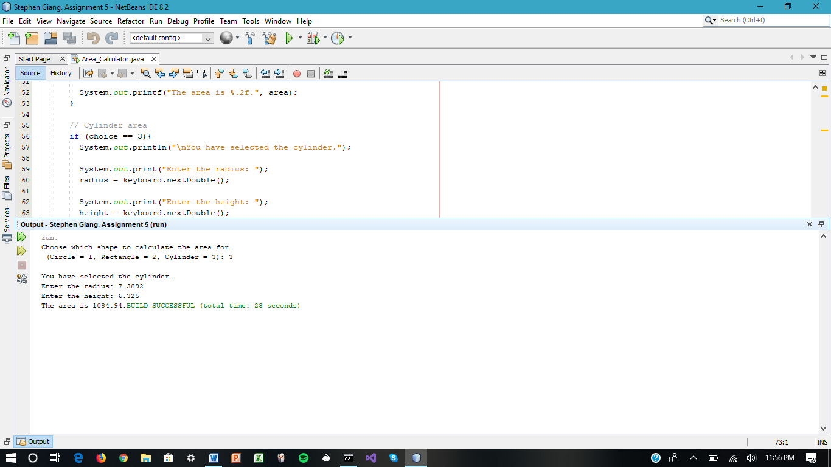

**Note:**

*If you can't Submit the Solution through the MPL's Workbench. Once you have filled in the required information, save the file to your flash drive / hard disk. Then, you can submit it to your instructor through your Blackboard Course for review and grading.*

**Appendix**

1. **Area Class (73088)**

Write a class that has three overloaded static methods for calculating the areas of the

following geometric shapes:

- circles

- rectangles

- cylinders

Here are the formulas for calculating the area of the shapes.

Area of a circle: Area = π r2

where p is Math.PI and r is the circle's radius

Area of a rectangle: Area = Width x Length

Area of a cylinder: Area = π r2 h

where p is Math.PI, r is the radius of the cylinder's base, and

h is the cylinder's height

Because the three methods are to be overloaded, they should each have the same name, but different parameter lists. Demonstrate the class in a complete program.

1. **A LandTract Class (71119)**

Make a LandTract class with the following fields:

• length - an int containing the tract's length

• width - an int containing the tract's width

The class should also have the following methods:

• area - returns an int representing the tract's area

• equals - takes another LandTract object as a parameter and returns a boolean saying

whether or not the two tracts have the same dimensions (This applies regardless of whether the dimensions match up. i.e., if the length of the first is the same as the width of the other and vice versa, that counts as having equal dimensions.)

• toString - returns a String with details about the LandTract object in the format:

LandTract object with length 30 and width 40

(If, for example, the LandTract object had a length of 30 and a width of 40.)

Write a separate program that asks the user to enter the dimensions for the two tracts of

land (in the order length of the first, width of the first, length of the second, width of the second). The program should print the output of two tracts' toString methods followed by a sentence stating whether or not the tracts have equal dimensions. (If the tracts have the same dimensions, print, "The two tracts have the same size." Otherwise, print, "The two tracts do not have the same size.") Print all three statements on separate lines.

1. **Parking Ticket Simulator (73089)**

For this assignment you will design a set of classes that work together to simulate a police officer issuing a parking ticket. You should design the following classes:

- The ParkedCar Class: This class should simulate a parked car. The class's responsibilities are as follows:

- To know the car's make, model, color, license number, and the number of minutes

that the car has been parked.

- The ParkingMeter Class: This class should simulate a parking meter. The class's only

responsibility is as follows:

- To know the number of minutes of parking time that has been purchased.

- The ParkingTicket Class: This class should simulate a parking ticket. The class's

responsibilities are as follows:

- To report the make, model, color, and license number of the illegally parked car

- To report the amount of the fine, which is $25 for the first hour or part of an

hour that the car is illegally parked, plus $10 for every additional hour or part of

an hour that the car is illegally parked

- To report the name and badge number of the police officer issuing the ticket

- The PoliceOfficer Class: This class should simulate a police officer inspecting parked

cars. The class's responsibilities are as follows:

- To know the police officer's name and badge number

- To examine a ParkedCar object and a ParkingMeter object, and determine whether

the car's time has expired

- To issue a parking ticket (generate a ParkingTicket object) if the car's time has

expired

Write a program that demonstrates how these classes collaborate. Make the aforementioned classes nested classes within the class containing your main method; only this outermost class can be declared public.